**Dream home case-study**

(By: Vanshika Malviya)

Github repository link: <https://github.com/vanshika05bablr-cell/Dreamhome_case.git>

This is a **dream home case study** for which we have to do fact findings that includes: mission statement, mission objectives, system definition, sample user view, requirement gathering and finally the ER Model. Since the case study conveys the data of mostly **branch and staff**, we’ll proceed in sample user views from their ends only.

**Mission statement:**

The purpose of the DreamHome DB system is to maintain the data that is used and generated to support property rental business for our **clients and property owners** and to facilitate the cooperation and sharing of information between **branches and staff**.

**Mission objective:**

**Branch**

* **To maintain data on:** Unique branch numbers, street, city, and postcode details for each office branch.
* **To perform searches on:** Branches by their city and other location details.
* **To track the status of:** N/A (no explicit status can be seen for branches within the provided schema).
* **To report on:** Comprehensive details of all branches, including their unique identifiers and geographical information.

**Staff**

* **To maintain data on:** Unique staff numbers, first and last names, positions, sex, dates of birth, salaries (including currency), and their assigned branch numbers.
* **To perform searches on:** Staff members by their unique number, name, position, salary, or the branch they are associated with.
* **To track the status of:** The assignment of staff members to a specific branch.
* **To report on:** All personal and professional details of staff members, their salaries, and their branch affiliations.

**PrivateOwner**

* **To maintain data on:** Unique owner numbers, first and last names, structured address (street, city, postcode), and telephone numbers for private property owners.
* **To perform searches on:** Private owners by their unique number, name, or contact details.
* **To track the status of:** N/A (no explicit status tracked for private owners within the provided schema).
* **To report on:** Full contact and identification details for all private property owners.

**PropertyForRent**

* **To maintain data on:** Unique property numbers, street, city, postcode, property type, number of rooms, monthly rent, associated owner number, managing staff member (if assigned), and managing branch number.
* **To perform searches on:** Properties based on location, type, number of rooms, rent range, managing staff, or managing branch.
* **To track the status of:** Which staff member is assigned to manage a property, and the branch responsible for it.
* **To report on:** All descriptive and financial details of properties available for rent, including their ownership and management assignments.

**Client**

* **To maintain data on:** Unique client numbers, first and last names, telephone numbers, preferred accommodation types, maximum rent limits, and the branch where they registered. Also maintains their active status (Open or Closed).
* **To perform searches on:** Clients by their unique number, name, preferred property characteristics, or registration branch.
* **To track the status of:** Whether a client is actively looking for a property (Open) or has secured a lease (Closed), with automatic updates upon lease creation.
* **To report on:** Comprehensive client profiles, including their preferences and current status in the rental process.

**Lease**

* **To maintain data on:** Auto-incrementing unique lease numbers, associated client and property numbers, rent start and end dates, agreed rent amounts, and payment methods.
* **To perform searches on:** Leases by client, property, or specific date ranges.
* **To track the status of:** The validity period of each lease and its associated payment method.
* **To report on:** All contractual details of rental agreements, including their financial terms and duration.

**Newspapers**

* **To maintain data on:** Auto-incrementing unique advertisement numbers, newspaper names, addresses (street, city, postcode), telephone numbers, contact names, associated property numbers, advertisement dates, and advertising costs.
* **To perform searches on:** Advertisements by newspaper, property advertised, date, or cost.
* **To track the status of:** Which properties have been advertised, where, and the associated costs.
* **To report on:** Details of all property advertisements, including publication and financial information.

**System definition:**

| **Profile** | **Strong Entities** |
| --- | --- |
| **Branch** | Branch no, street, city, postcode, active clients, staff count, revenue generated |
| **Staff** | Staff no, First name, Last name, position, sex, dob, salary, currency |
| **PrivateOwner** | Owner no, First name, Last name, street, city, postcode, tel no |
| **PropertyForRent** | Property no, street, city, postcode, type, rooms, rent |
| **Client** | Client no, First name, Last name, tel no, preference type, max rent, status |
| **Lease** | Lease no, rent start, rent end, rent amount, payment method |
| **Newspapers** | Newspaper adv no, newspaper name, street, city, postcode, telephone, contact name, date advertised, cost to advertise |

**Sample user view table:**

1. **For Branch**

| **Role title** | **Description** | **Entities used** |
| --- | --- | --- |
| Branch Manager | Oversees all operations of their branch including staff, properties, and client registrations. | Branch, Staff, Client, Property for rent, Lease |
| Performance Analyst | Analyzes branch-level metrics like revenue, staff productivity, and active client count. | Branch, Lease, Staff |
| Client Relations Officer | Manages communication and follow-up with clients from their branch. | Client, Lease, Branch |
| Property Overview Analyst | Tracks properties assigned to the branch and monitors occupancy/vacancy and assignments | Property for rent, Staff, Branch |

1. **For staff**

| **Role title** | **Description** | **Entities used** |
| --- | --- | --- |
| Property Manager | Manages specific properties assigned to them, including rent collection and coordination with owners. | Property for rent, Private owner, Lease |
| Client Executive | Assists clients in finding suitable properties, records their preferences, and helps match listings. | Client, Property for rent, Lease |
| Leasing Agent | Handles lease creation and termination, and ensures proper payment and documentation. | Lease, Client, Property for rent |
| Sales Assistant | Supports day-to-day activities including client data entry, follow-ups, and coordination. | Client, Property for rent, Staff |

**Requirement gatherings:**

1. (a) Access chart for branches

| **Data entity** | **Access type** | **Branch manager** | **Performance analysts** | **Client relations officer** | **Property overview analyst** | **Justification** |
| --- | --- | --- | --- | --- | --- | --- |
| **Branch no.** | Maintain | ✅ | ❌ | ❌ | ❌ | Manager assigns branch-level identifiers |
|  | Query | ✅ | ✅ | ✅ | ✅ | All roles require access to branch reference |
|  | Report | ✅ | ✅ | ❌ | ❌ | Needed for operations and reporting |
| **Street** | Maintain | ✅ | ❌ | ❌ | ❌ | Updated when branch address changes |
|  | Query | ✅ | ✅ | ✅ | ✅ | Used in filtering/searching branches |
|  | Report | ✅ | ✅ | ❌ | ❌ | Address-based analytics |
| **City** | Maintain | ✅ | ❌ | ❌ | ❌ | Maintained centrally by branch head |
|  | Query | ✅ | ✅ | ✅ | ✅ | City-based searches and filtering |
|  | Report | ✅ | ✅ | ❌ | ❌ | City distribution reports |
| **Postcode** | Maintain | ✅ | ❌ | ❌ | ❌ | Controlled for branch identity |
|  | Query | ✅ | ✅ | ✅ | ✅ | Used for local searches |
|  | Report | ✅ | ✅ | ❌ | ❌ | For operational summaries |
| **Active clients** | Maintain | ❌ | ❌ | ❌ | ❌ | System-updated from client status |
|  | Query | ✅ | ✅ | ✅ | ❌ | Used by all for checking active workload |
|  | Report | ✅ | ✅ | ✅ | ❌ | Reports for branch activity/performance |
| **Staff count** | Maintain | ❌ | ❌ | ❌ | ❌ | Auto-calculated or system-generated |
|  | Query | ✅ | ✅ | ❌ | ❌ | Helps monitor team size at each branch |
|  | Report | ✅ | ✅ | ❌ | ❌ | For internal HR dashboards |
| **Revenue generated** | Maintain |  |  | ❌ | ❌ | Auto-calculated from leases |
|  | Query | ✅ | ✅ | ❌ | ❌ | Key for financial analysis |
|  | Report | ✅ | ✅ | ❌ | ❌ | Used in revenue performance dashboards |

(b) Centralised view

| **Columns** | **Branch manager** | **Performance analysts** | **Client relations officer** | **Property overview analyst** |
| --- | --- | --- | --- | --- |
| **Branch no.** | ✅ | ✅ | ✅ | ✅ |
| **Street** | ✅ | ✅ | ✅ | ✅ |
| **City** | ✅ | ✅ | ✅ | ✅ |
| **Postcode** | ✅ | ✅ | ✅ | ✅ |
| **Active clients** | ✅ | ✅ | ✅ | ❌ |
| **Staff count** | ✅ | ✅ | ❌ | ❌ |
| **Revenue generated** | ✅ | ✅ | ❌ | ❌ |

(c) System requirement

| **Attribute** | **Initial Size** | **Growth Rate** | **Record Search & Volume** | **Networking / Shared Access** | **Performance Needs** | **Security** | **Backup & Recovery** | **Legal / Justification** |
| --- | --- | --- | --- | --- | --- | --- | --- | --- |
| **branch_no** | ~50 branches | Very low | Common filter in queries | Used across all departments | Fast joins with staff, leases | Admin-only edits | Daily backup | Identifies operational unit |
| **street** | One per branch | Rare | Used in full address lookups | Shared with property and client modules | Moderate | Low sensitivity | On update | Location validation |
| **city** | Limited set | Static | Filtered often (~200/day) | Shared across modules | High lookup speed | Low sensitivity | Standard backup | For region-based analysis |
| **postcode** | Unique per branch | Static | Used in location searches | Shared with ads & client service | Low | Public info | Standard backup | Geographic analytics |
| **active_clients** | System-generated | Medium | Queried for workload reports | Shared with client & leasing teams | Real-time updates needed | Read-only | Synced with client data | Operational monitoring |
| **staff_count** | Auto-calculated | Medium | Used in HR dashboards | Shared with HR, managers | Moderate | Internal only | Derived from staff data | Headcount reporting |
| **revenue_generated** | Calculated | Med–High | Queried in financial reports | Shared with finance & managers | High (aggregates needed) | Restricted to finance roles | Monthly backup | Needed for financial audits |

2. (a) Access chart for staff

| Data entity | Access type | Property manager | Client executive | Leasing agent | Sales assistant | Justification |
| --- | --- | --- | --- | --- | --- | --- |
| **Staff no.** | Maintain | ✅ | ❌ | ❌ | ❌ | Branch managers assign/manage staff |
|  | Query | ✅ | ✅ | ✅ | ✅ | Required for identifying responsible staff |
|  | Report | ✅ | ✅ | ❌ | ❌ | Used in reporting structure |
| **First name** | Maintain | ✅ | ❌ | ❌ | ❌ | Editable in staff records |
|  | Query | ✅ | ✅ | ✅ | ✅ | Needed to reference or search |
|  | Report | ✅ | ✅ | ❌ | ❌ | Staff activity reporting |
| **Last name** | Maintain | ✅ | ❌ | ❌ | ❌ | Editable in staff records |
|  | Query | ✅ | ✅ | ✅ | ✅ | Needed to reference or search |
|  | Report | ✅ | ✅ | ❌ | ❌ | Staff activity reporting |
| **Position** | Maintain | ✅ | ❌ | ❌ | ❌ | Manager sets/updates role |
|  | Query | ✅ | ✅ | ✅ | ✅ | Required to know who does what |
|  | Report | ✅ | ✅ | ❌ | ❌ | Used in team reports |
| **Sex** | Maintain | ✅ | ❌ | ❌ | ❌ | For HR/legal use only |
|  | Query | ✅ | ❌ | ❌ | ❌ | Visibility only where needed |
|  | Report | ✅ | ❌ | ❌ | ❌ | For internal HR statistics |
| **DOB** | Maintain | ✅ | ❌ | ❌ | ❌ | Sensitive info—HR only |
|  | Query | ✅ | ❌ | ❌ | ❌ | Used for age-related policies |
|  | Report | ✅ | ❌ | ❌ | ❌ | For internal summaries only |
| **Salary** | Maintain | ✅ | ❌ | ❌ | ❌ | Confidential—Manager level only |
|  | Query | ✅ | ❌ | ❌ | ❌ | Only view access to track costs |
|  | Report | ✅ | ❌ | ❌ | ❌ | Used in compensation reports |
| **Branch no.** | Maintain | ✅ | ❌ | ❌ | ❌ | Staff are linked to branches by manager |
|  | Query | ✅ | ✅ | ✅ | ✅ | Used to filter and group staff by branch |
|  | Report | ✅ | ✅ | ❌ | ❌ | Used in regional performance reports |

(b) Centralised view

| Columns | Property manager | Client executive | Leasing agent | Sales assistant |
| --- | --- | --- | --- | --- |
| **Staff no.** | ✅ | ✅ | ✅ | ✅ |
| **First name** | ✅ | ✅ | ✅ | ✅ |
| **Last name** | ✅ | ✅ | ✅ | ✅ |
| **Position** | ✅ | ✅ | ✅ | ✅ |
| **Sex** | ✅ | ❌ | ❌ | ❌ |
| **DOB** | ✅ | ❌ | ❌ | ❌ |
| **Salary** | ✅ | ❌ | ❌ | ❌ |
| **Branch no.** | ✅ | ✅ | ✅ | ✅ |

(c) System requirement

| **Attribute** | **Initial Size** | **Growth Rate** | **Record Search & Volume** | **Networking / Shared Access** | **Performance Needs** | **Security** | **Backup & Recovery** | **Legal / Justification** |
| --- | --- | --- | --- | --- | --- | --- | --- | --- |
| **staff_no** | ~150–200 | Low–Med | Used in most queries (~100/day) | Shared across ops & HR | Fast lookups needed | Admin-only | Daily backup | Unique identifier |
| **first_name** | One per record | Rare | Used for search & ID | Shared for operations | Moderate | Low sensitivity | Standard backup | Employee ID |
| **last_name** | One per record | Rare | Used in reports/search | Shared across teams | Moderate | Low sensitivity | Standard backup | Reporting clarity |
| **position** | One per staff | Low change | Role-based filters | Shared across departments | High | HR edits only | Versioned updates | Org structure clarity |
| **sex** | Static | None | Rarely queried | HR-only access | Low | Sensitive | Encrypted backup | Legal compliance |
| **dob** | Static | None | Age queries (low freq) | HR-only access | Low | Sensitive | Encrypted backup | Age-based policies |
| **salary** | One per staff | Annual change | Used in payroll reports | Finance/HR only | Moderate | Encrypted & restricted | Monthly payroll backup | Pay confidentiality |
| **currency** | Static | Rare | Used in financial reports | Finance only | Low | Tied to salary access | Finance backup | For currency alignment |
| **branch_no** | Foreign key | Varies with transfers | Grouping/filtering (~50/day) | Shared across modules | Moderate | Admin-only edits | Synced with staff record | Staff assignment tracking |

**ER Model:**

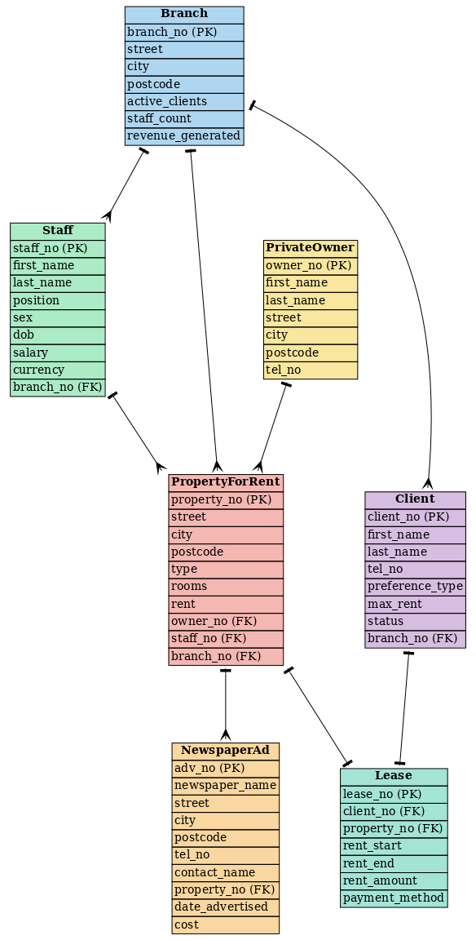

**\*** The lines here show the relationship between the entities, and their cardinality. T end shows 1 and crow feet show multiple, this signifies that the relation starting from T end and ending on crow feet has cardinality of 1:M.